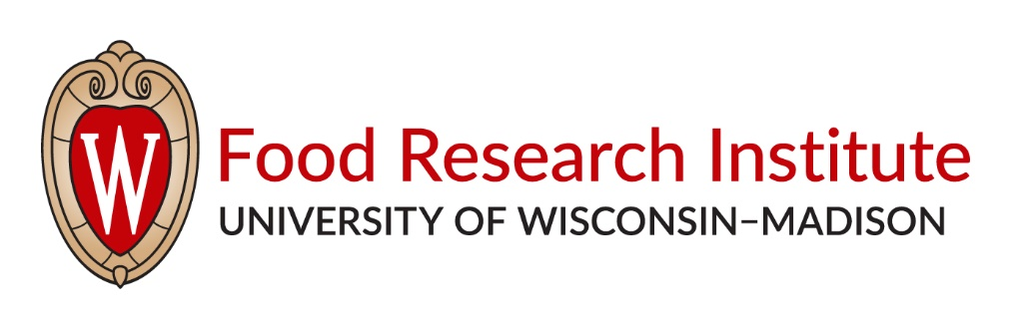
2020 Summer Undergraduate Research Program
Food Microbiology and Food Safety Research

Dates: Tuesday, May 26th through Tuesday, July 21st, 2020.

Applications Due: Friday, February 8th, 2020

Stipend: $4,000

Research Project: Each student studies and conducts research in the laboratory of a mentor on a project related to food safety. Students with significant conflicts such as summer classes, extended trips, etc. should state these on their application. Students who will graduate before Dec. 2020 will not be considered nor will those receiving Hilldale awards.

Weekly Tutorial: Each week, students participate in a tutorial session in which they learn about and discuss timely issues with one or more speakers from campus or the food industry.

Field Trips: Students take two field trips to Wisconsin food production facilities.

To Apply: Please e-mail the following by Friday, February 7th, 2020 to Adam Borger at adam.borger@wisc.edu:
- A letter stating your interest and experience in food microbiology, and how the program will help you achieve your career goals.
- A resume.
- The name of your proposed mentor who agrees to support your project in his or her lab — See the Food Research Institute website for possible mentors and their research programs: www.fri.wisc.edu.
- An unofficial transcript.
- An “Instructor Evaluation Form”, to be filled out by a professor or laboratory instructor able to evaluate your strengths and capabilities. The form may be found at: https://fri.wisc.edu/about_students.php. Please have the evaluator send this form directly to Adam Borger (adam.borger@wisc.edu).

Questions? Contact Adam Borger: adam.borger@wisc.edu, 608-263-7062.

